Project Planning Phase
Project Planning Template (Product Backlog, Sprint Planning, Stories, Story points)

Date | 02/10/2026
Team ID | SWTID-2026-8585
Project Name | IMPORT DATA USING TRANSFORM MAPS (SPREADSHEET)
Maximum Marks | 5 Marks

Product Backlog, Sprint Schedule, and Estimation (4 Marks)
This backlog estimates the twelve approved user stories for the ServiceNow employee spreadsheet import. It uses two 10-workday sprints and Fibonacci story-point estimates (1, 2, 3, 5). The story-point split is a planning baseline and should be reviewed by the delivery team.
Sprint | Functional Requirement (Epic) | User Story Number | User Story / Task | Story Points | Priority | Team Members
Sprint-1 | Source and target setup | US-1 | As an HR data coordinator, I can prepare an employee workbook with Employee ID, Name, Email, Department, and Location so each row can be mapped. | 2 | High | HR Data Coordinator
Sprint-1 | Source and target setup | US-2 | As a ServiceNow administrator, I can create u_employee_test with the required employee fields so imported rows have a defined destination. | 3 | High | ServiceNow Administrator
Sprint-1 | Source and target setup | US-3 | As a ServiceNow administrator, I can create u_employee_import as the staging table so spreadsheet rows can be loaded before transformation. | 2 | High | ServiceNow Administrator
Sprint-1 | Spreadsheet load and mapping | US-4 | As an HR data coordinator, I can load the prepared workbook into u_employee_import so source rows are staged for transformation. | 3 | High | HR Data Coordinator
Sprint-1 | Spreadsheet load and mapping | US-5 | As a ServiceNow administrator, I can map Employee ID, Name, Email, Department, and Location to the target employee fields. | 3 | High | ServiceNow Administrator
Sprint-1 | Spreadsheet load and mapping | US-6 | As a ServiceNow administrator, I can coalesce on Employee ID so matching employees are updated and new employees are inserted without duplicates. | 3 | High | ServiceNow Administrator
Sprint-2 | Transform and verification | US-7 | As an HR data coordinator, I can run the transform map on the staged import set so employee rows are written to u_employee_test. | 2 | High | HR Data Coordinator
Sprint-2 | Transform and verification | US-8 | As an HR data coordinator, I can review Transform History so row outcomes and errors can be checked. | 2 | High | HR Data Coordinator
Sprint-2 | Transform and verification | US-9 | As an HR data coordinator, I can inspect u_employee_test with all five employee fields visible so I can verify imported records. | 1 | High | HR Data Coordinator
Sprint-2 | Transform and verification | US-10 | As an HR data coordinator, I can repeat the same import so existing Employee IDs are updated rather than duplicated. | 2 | High | HR Data Coordinator
Sprint-2 | Employee reporting | US-11 | As a ServiceNow administrator, I can create Department and Location count reports and an employee list so HR can review imported data. | 3 | Medium | ServiceNow Administrator
Sprint-2 | Employee reporting | US-12 | As an HR data coordinator, I can view the three employee reports on the Employee Analytics Dashboard so the population is visible in one place. | 2 | Medium | HR Data Coordinator

Project Tracker, Velocity & Burndown Chart: (4 Marks)
Sprint | Total Story Points | Duration | Sprint Start Date | Sprint End Date (Planned) | Story Points Completed (as on Planned End Date) | Sprint Release Date (Actual)
Sprint-1 | 16 | 10 workdays | 05 Oct 2026 | 16 Oct 2026 | Pending sprint review | Pending
Sprint-2 | 12 | 10 workdays | 19 Oct 2026 | 30 Oct 2026 | Pending sprint review | Pending

Velocity:
Planned velocity: 28 backlog points across two 10-workday sprints = 14 planned points per sprint. Average planned rate = 14 / 10 = 1.4 story points per workday. This is an initial estimate, not measured team velocity; recalibrate after Sprint 1.


Burndown Chart:
Planned burndown: the chart shows the ideal remaining-work line for each sprint. Update actual remaining points at the end of each workday during delivery; no actual progress has been recorded yet.
Ideal remaining-work plan (record actual remaining points daily)
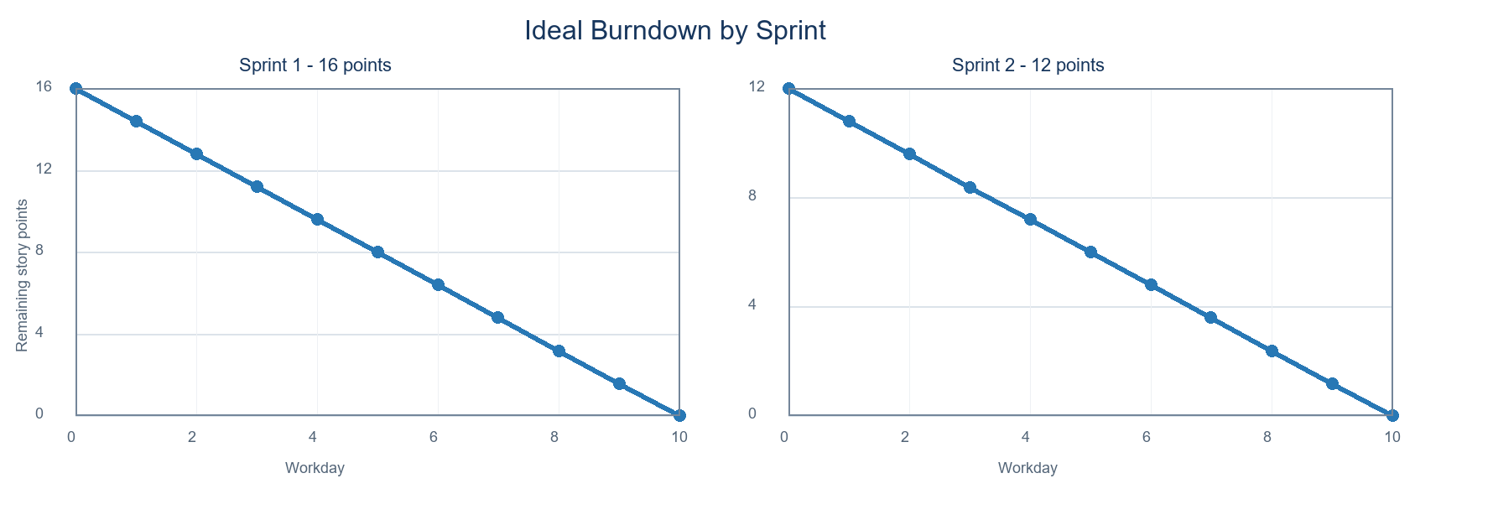
https://www.visual-paradigm.com/scrum/scrum-burndown-chart/
https://www.atlassian.com/agile/tutorials/burndown-charts

Reference:
https://www.atlassian.com/agile/project-management
https://www.atlassian.com/agile/tutorials/how-to-do-scrum-with-jira-software
https://www.atlassian.com/agile/tutorials/epics
https://www.atlassian.com/agile/tutorials/sprints
https://www.atlassian.com/agile/project-management/estimation
https://www.atlassian.com/agile/tutorials/burndown-charts

